SQUID INK
Producer/General Management

General Manager Kevin Magos
Website and Graphic Designer www.ronnie-designs.com
Legal Counsel Chris Riano
Music Copyist Brandon James Gwinn Music Prep
Exclusive Booking Representative AWA/OBB

Carmela, Delphine & Squid Ink Productions
Wish to Thank…

Jim and Julie Falzone
Brian and Debra Lavender
Stacy O’Neill
Dave and Lisa Magos
Richard and Susan Logothetis and The Lycian Center Staff

Make-up design and cosmetics courtesy of Jay Falzone
www.MotivesCosmetics.com/JayFalzone




Squid Ink Productions
Presents

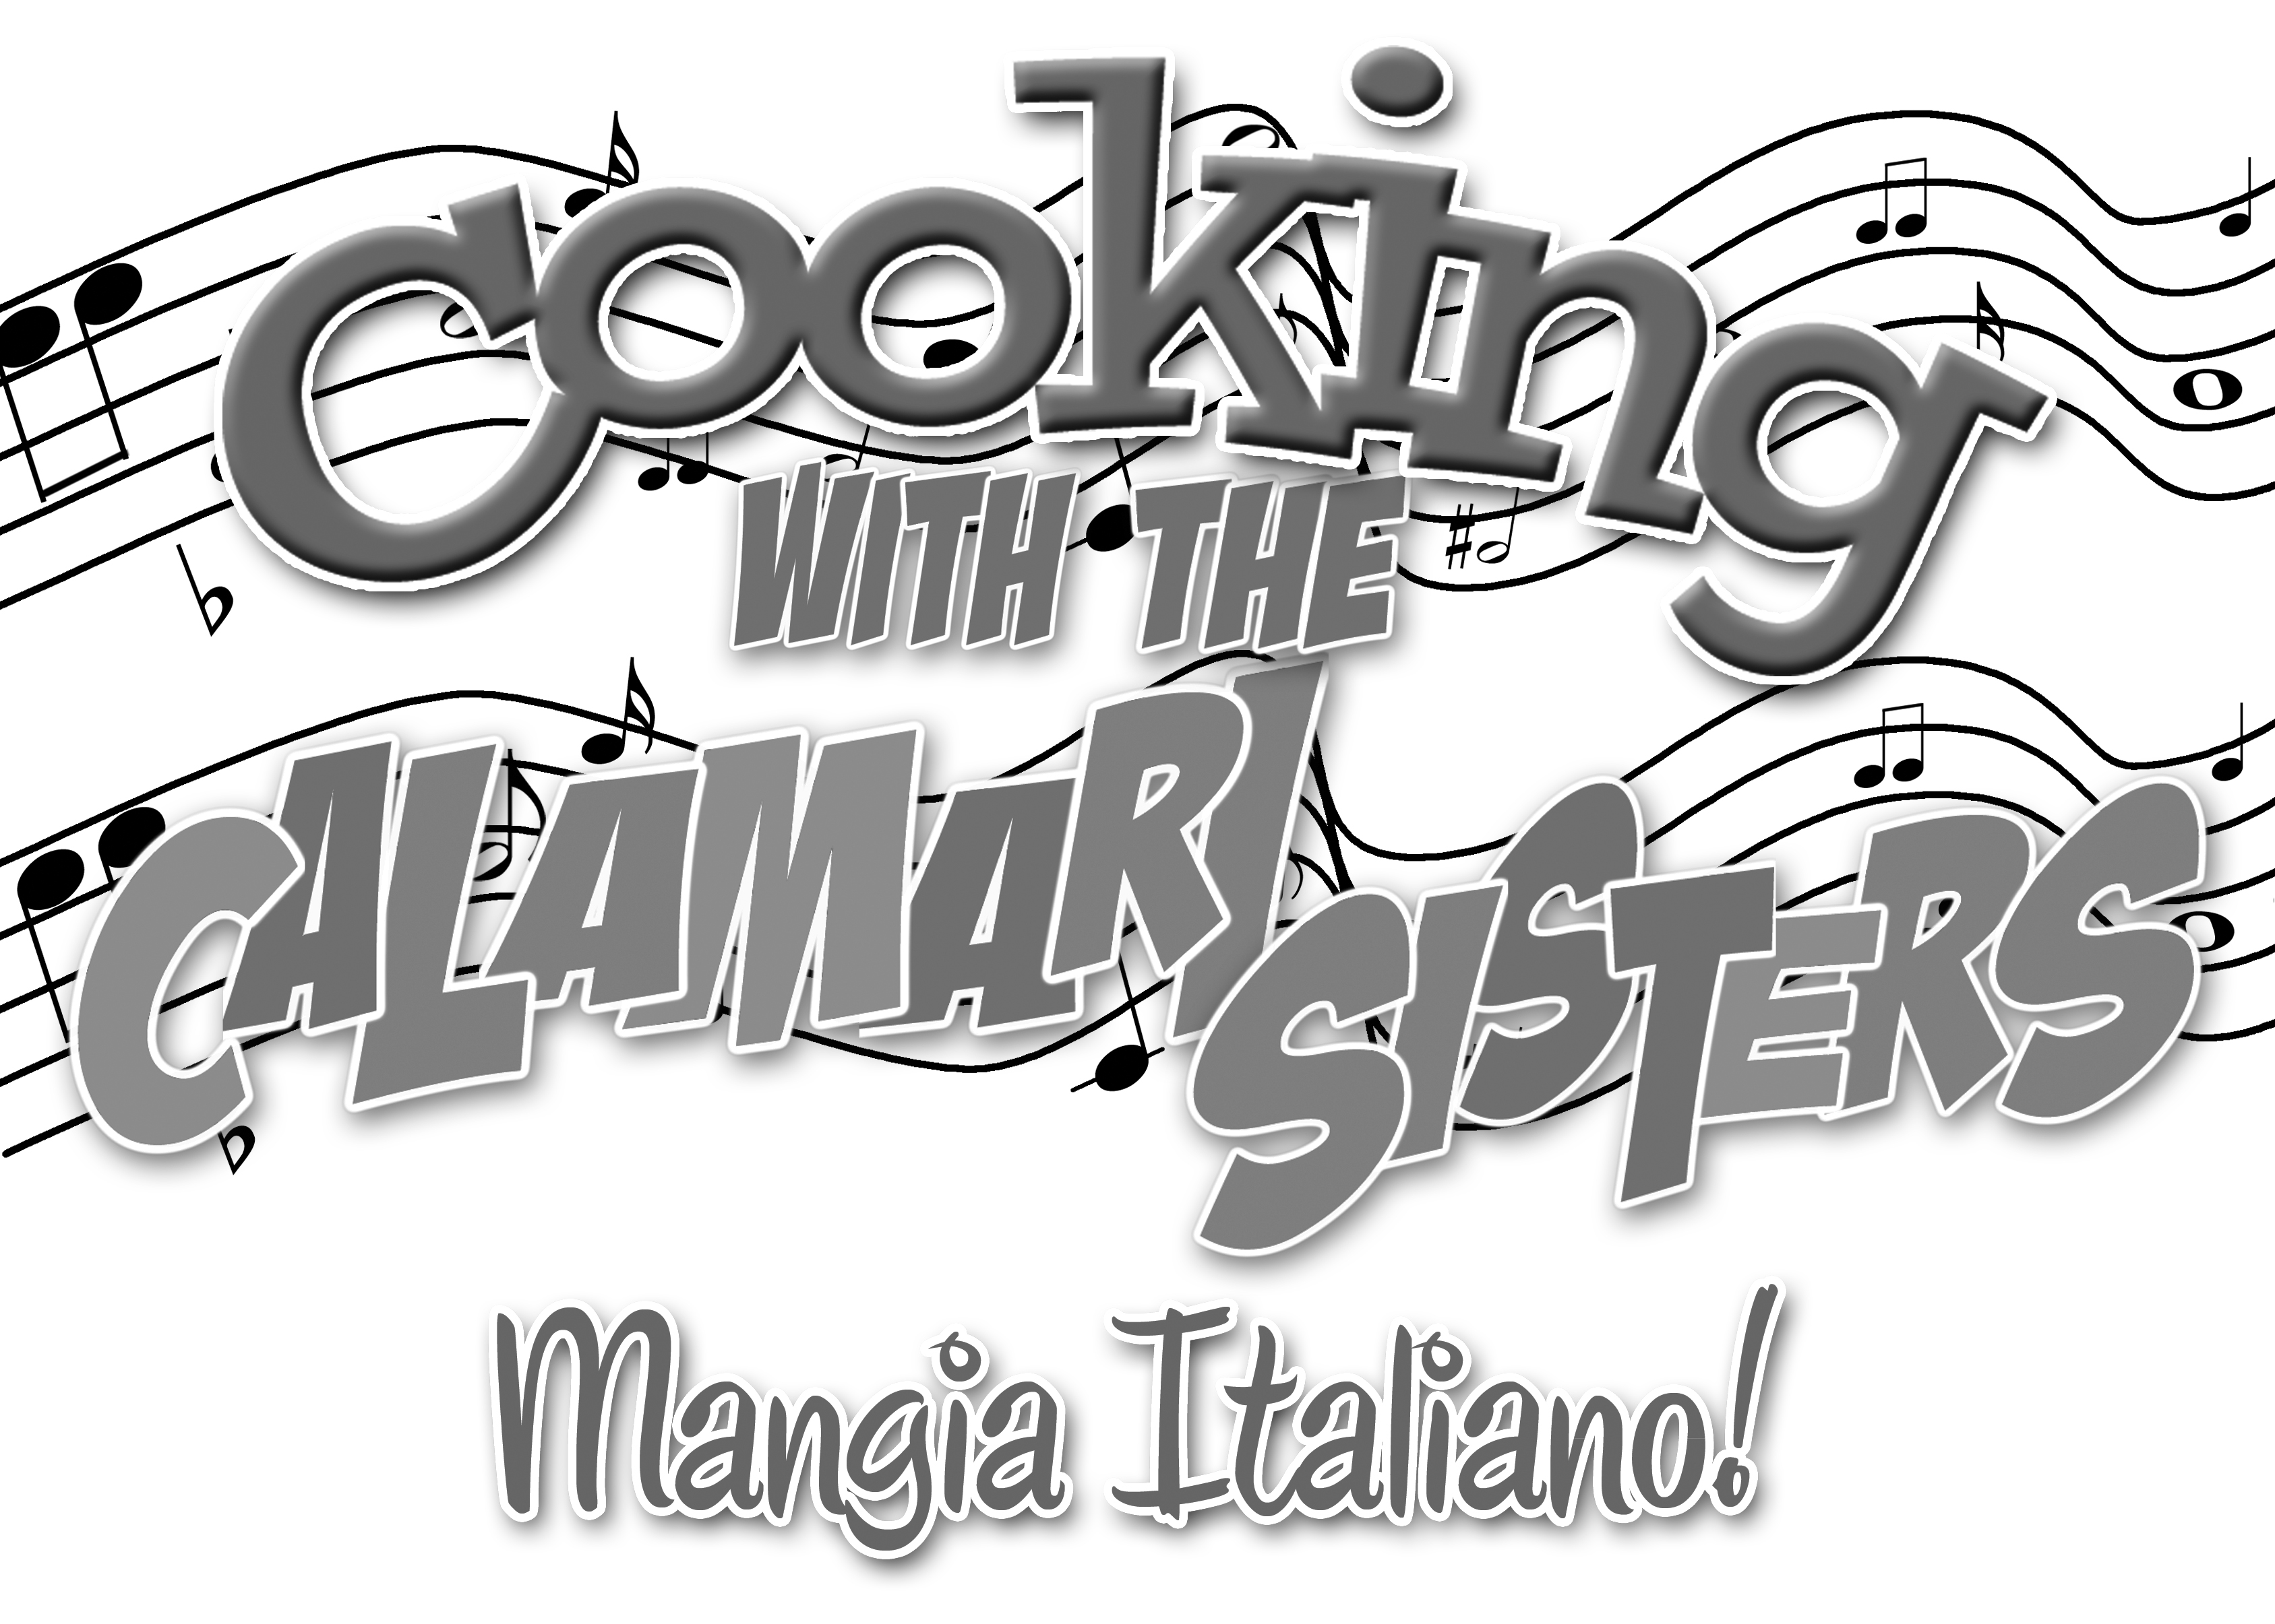

Created by
JAY FALZONE, DAN LAVENDER and STEPHEN SMITH

Featuring
DELPHINE and CARMELA CALAMARI

Orchestrations and Arrangements by Scenic Design by
MARCO DiCRESCENDO BIFF CALAMARI

Lighting Design by Costume Design by
TONY “SPARKY” OSCURAMENTO ROBIN McBOBBIN

Production Stage Manager
LUCY LICCAPUNANNI

Entire Production Directed and Choreographed by
FRANCIS FORD COPPOLA

… 
shooting on location in Bay Ridge, Brooklyn

Thank you for being part of our studio audience for
Mangia Italiano!

Episode 173: "What Do You Mean You're Full?
Shut Up And Finish Your Plate!"

The Menu for today's show includes:

COURSE #1:
Antipasto

COURSE #2:
Appetizer

COURSE #3:
Main Dish

SPECIALTY:
Palate Cleansing

COMMERCIAL BREAK:
(Brief Intermission)

COURSE #4:
Dessert

PLEASE turn off your cell phones and refrain from
taking flash photography...

...or you'll be sleeping with the fishes!!!


SQUID INK PRODUCTIONS (Producer) is a New York based production company focused on theatrical development, investment, and producing, as well as event and design services. Theatrical credits: Cocktails With Coward (Northern Stage, Don't Tell Mama), The Lightning Field (Fringe 2005 – Winner of Best Play and GLAAD Media Award), Ethan Frome: The Musical (York Theatre Developmental Workshop), White Noise (NYMF 2007), The Greatest Holiday Musical…Ever! (Don't Tell Mama), Irving Berlin's I Love A Piano (First National), Booking Consultant on several national tours including The Wedding Singer (Second National) through Off Broadway Booking. National Tours: Swing For Victory and Cooking With The Calamari Sisters. Look for the other Calamari Sisters’ hit touring property around the country this coming holiday season: Christmas With The Calamari Sisters! In development for The Calamari Sisters’ Big Fat Italian Wedding, premiering in Rochester in May 2012. Event credits: Deborah Cox In Concert, Dixie's Tupperware Party, Naked Boys Singing Memorial Day Festival (all Fire Island Pines). Design credits: Stormy Weather (Interart), The Tempest (Looking Glass, Spotlight On Award Winner), The Crown Point Festival, ShakespeareNYC Resident Lighting Design (TheatreRow), Lighting Coordinator Pace University’s Michael Schimmel Center for the Arts 2005-2007. Clients included: Inside the Actor's Studio, NY1 News, People's Beijing Theater, and Kanye West. www.livelyarts.net

JAY FALZONE (Co-Creator) feels extremely fortunate to have been invited to the cocktail-party-gone-awry that was the genesis of Cooking With The Calamari Sisters. A Rochester native and Syracuse University alum, he grew up in a full-blooded Italian family and is grateful to have the opportunity to pay homage to the wonderful craziness of an Italian upbringing. Other writing credits: Parenting 101 (Co-writer/ Director/ Choreographer), and You Don’t Know Jack (Book/ Lyrics), an adult retelling of the Jack & Jill nursery rhyme. Directing/ Choreographing credits: Bush Wars (Off-Broadway), Ain’t Misbehavin’ (National Tour), Snoopy (50th Anniversary National Tour), Shout, The Mod Musical (Chicago; National Tour), 42nd Street (Naples, FL), and I Love You, You’re Perfect, Now Change! (Rochester, NY - 9-year run). Currently, he is working with the original producer of Menopause, The Musical on a new parody musical entitled Divorce Party, The Musical as writer and director. Performances of Divorce Party are scheduled to begin in Winter of 2012, Jay wishes to dedicate this show to his grandmother, Delphine Pierri, for the inspiration, humor, and heart to create his part of Cooking With The Calamari Sisters. Jay also freelances as a make-up artist (www.MotivesCosmetics.com/JayFalzone).
DAN LAVENDER (Co-Creator) never imagined that an Italian mother and a dinner party with friends would lead to this show. As a director: Off Broadway: Ethan Frome: The Musical (York Theatre), Swing For Victory (World Premiere - York Theatre). Off-Off Broadway: Cocktails With Coward (Don’t Tell Mama), and Soar Like An Eagle (The Lion). Regional: Cocktails With Coward (Northern Stage) and Oh, Boy! (Berkshire Theatre Festival). National Tours: Swing For Victory!, Cooking With The Calamari Sisters, Christmas With The Calamari Sisters! Artistic Associate (Northern Stage), Resident Director/Choreographer (Northern Lights Playhouse). Assistant Director: Lizzie Borden, They All Laughed (Goodspeed), Zorba, My Fair Lady, Brownstone, A Saint She Ain’t, HMS Pinafore (Berkshire Theatre Festival), Camelot (MUNY), An Ideal Husband (Papermill) and many more. Resident of Brooklyn and Fire Island Pines, NY, Dan is an associate member of the SSDC. He attended Pace University and Dartmouth College. Thanks to my grandmother, Lucy Bocchino, who taught me that a wooden spoon is really called a cucchiaio, and Love to Kevin Magos, who makes it all worthwhile. www.livelyarts.net/theatrical
STEPHEN SMITH (Co-Creator) is head-over-HEELS in love with Cooking With The Calamari Sisters, this being his first true collaboration on a new musical. The only creator that’s not Italian, he’s just happy to have survived the process. A graduate of the University of Tennessee, Stephen has worked with theatres across the country and internationally, even as far as Disney Tokyo. Dance credits: choreographing The Anderson County Maverettes & Swingin’ Blue (…no, really, he couldn’t make that up…) and working with Rockettes choreographer John Dietrich. He designed costumes for Autumn Moon (a new werewolf rock opera), created puppets for Autumn Moon and Fool’s Paradise and has had artwork commissioned by Florida Power and Light Company, as well as several private buyers. Outside of theatre, Stephen has held jobs observing manatees, raising endangered sea turtles, manning the drive thru at Schlotzsky’s Deli, and dancing on the BIG piano at FAO Schwartz in NYC. He wishes to dedicate this show to Dan, friends and family, the cocktail hour that inspired the show, and especially Jay without whom none of this would be possible. Love and blessings!


“All My Single Ladies” (Stewart / Nash / Harrell / Knowles)
“Barber of Seville” (Rossini / Sterbini)
“Botch-a-me” (Astore / Stanley / Rabagliati)
“Come On A My House” (Bagdasarian / Sarayan)
“Dirrty” (Aguilera / Redman / Cameron / Muhammad / Rockwilder)
“Hit Me With Your Best Shot” (Schwartz)
“I Can Cook Too” (Bernstein / Comden / Green)
“I Can’t Give You Anything But Love” (McHugh / Fields)
“I Got No Strings” (Harline / Washington)
“I’m A Brass Band” (Coleman / Fields)
“Italian Restaurant” (Joel)
“Italian Street Song” (Herbert / Young)
“I Wanna Be Loved By You” (Stothart / Ruby / Kalmar)
“Mambo Italiano” (Merrill)
“Maniac” (Matkosky / Sembello)
“Music And The Mirror” (Hamlisch)
“Nice ‘N’ Easy” (Bergman / Keith / Spence)
“Oops I Did It Again” (Martin / Rami)
“Orange Colored Sky” (DeLugg / Stein)
“Papa Don’t Preach” (Elliot / Madonna)
“Que Sera Sera” (Livingston / Evans)
“Sisters” (Berlin)
“Speak Softly Love” (Rota)
“Sway” (Ruiz / Gimbel)
“Tea For Two” (Youmans / Caesar)
“That’s Amore” (Warren / Brooks)
“These Boots Are Made For Walking” (Hazlewood)
“Tico Tico” (de Abreu)
“Tiptoe Through The Tulips” (Burke / Dubin)
“Tu Vuo Fa L’Americano” (Carosone / Salerno)
“Volare” (Modugno / Migliacci)
“What A Wonderful World” (Thiele / Weiss)
“Whip It” (Devo)
“Whistle While You Work” (Churchill / Harline)
“Zing Went The Strings Of My Heart” (Hanley)

CARMELA CALAMARI was born in Bay Ridge, NY, the lightest daughter of Rocco and Vittoria Calamari, weighing 15 pounds at birth. Carmela began turning heads with her cooking from a very young age, combining a lemonade stand with a kissing booth at the age of eight. After being promptly shut down by her uncle, and several of her customers mysteriously disappearing, she turned her attention to more conventional outlets and began competing in the Bay Ridge pageant circuit. While qualified, Carmela was crowned Miss Salami of Bay Ridge, first runner-up Miss Wooden Spoon of Bay Ridge, and Miss Congeniality for Miss Stuck Pig of Bay Ridge; always wowing the crowd with some extraordinary new and unusual talent. It was while competing for the famous Miss Macaroni of Greater Brooklyn when Carmela was allegedly caught feeding one of the judges minestrone soup out of her Gucci knock-off pump. Although never conclusively proven, she was disqualified from any and all future Italian pageants in all five boroughs. Never one to accept defeat, Carmela dove into helping her sister, Delphine, and their grandmother cater events at the Rigatoni Lodge, becoming the fastest cake frost-er in all of Brooklyn. In addition, she became the darling of the St. Lady of the Divine Pain High School’s Drama Club, playing such roles as Effie in “Dreamgirls,” Eliza DooLittle in “My Fairy Lady,” and Mary in “The Secret Garden.” After graduation, Carmela attended DeVry University for a year and a half before pursuing her dream of a life in the show biz. She came close to her big break when she was cast as Kathy Bates butt double, but the MPAA deemed the scene “of questionable taste,” and Carmela’s film debut was never seen. However, when her sister, Delphine, suggested they start a singing-dancing-cooking business together, Carmela knew it was the perfect marriage of her two favorite things: cooking and performing, and so Calamari Sisters’ Catering Company was born. Achieving neighborhood attention for their unusual catering style incorporating song-and-dance routines, she always knew that she needed a medium that would allow more people to experience her unique caliber of entertainment. Public access cable was the answer!! She became the star of MANGIA ITALIANO! Carmela wishes to thank her Uncle JoJo for never making good on his bets, and her devoted fans for their countless letters, pictures (both G-rated and otherwise), and articles of clothing (both laundered and otherwise) the past four years. Carmela wishes to leave you with a quote: “Dreams are like butterflies. Don’t let them go ‘cause they won’t come back. So hold onto them tight even if kills the butterfly.”
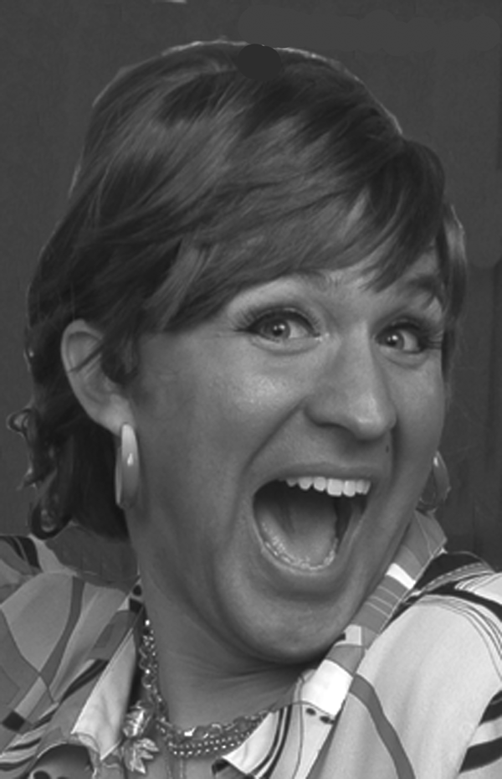
DELPHINE CALAMARI was born in Bay Ridge, NY, the eldest daughter of Rocco and Vittoria Calamari. By age seven, she was assisting her grandmother cater every major event at the legendary Rigatoni Lodge of the Brooklyn Federation of Italian-American Societies. Her love for meat began soon there after, and within a few years she was known throughout the borough as “that Italian girl that can tell you which butcher a sausage comes from with her eyes closed.” By the time Delphine was a young woman, it was widely believed that unless you served Delphine’s meatballs at your wedding reception, your marriage would be doomed and you would never conceive a son to carry on your family name. In addition to cooking, Delphine has always been interested in the arts, singing countless duets with her sister, Carmela, at St. Lawrence of the Roasted Martyrs Church and Convent. Their nativity of cold meats and dairy was always a huge crowd pleaser at Christmastime. Also, as a young girl, Delphine attended Miss FloFlo’s School of Dance for Bigger Girls, where she excelled until she was asked to leave due to an unfortunate fight with a fellow dancer, Tula Mercantelli, over a piece of Easter pie. Today, Tula is carrying her third illegitimate child by a third father, and it serves her right. Undaunted, Delphine was Founder and President of the Pasta and Meat Club at St. Lady of the Divine Pain High School, as well as unofficial Cookie Maker for the Drama Club, where she also landed such roles as Nurse Flinn in “One Flew Over The Cuckoo’s Nest,” the Kit Kat Club Janitor in “Cabaret,” and Rusty Charlie in “Guys And Dolls.” Upon graduating, she was fired from several restaurant jobs for forcing patrons to eat after they were full. Jobless, she teamed up with her sister, Carmela, and founded the borough-famous Calamari Sisters’ Catering Company. They soon became well-known for their song-and-dance-and-cooking routines, being hired by such notable public figures as Ed Koch, Hoda Kotb, and Nancy Harrigan. Knowing that the next natural step for them was television, when the opportunity presented itself, they grabbed it. Four years ago, their Uncle JoJo accidentally went swimming without taking off his cement block, and left them a large inheritance, which they used to finance their public access cable TV show, MANGIA ITALIANO. Delphine wishes to thank her family for all of their support (except her Aunt Viola, go to hell), especially Uncle Geno for being in the right place at the right time when this kitchen set fell off the back of that truck! Delphine sends much love to all of her fans, and invites them to mangia, MANGIA!
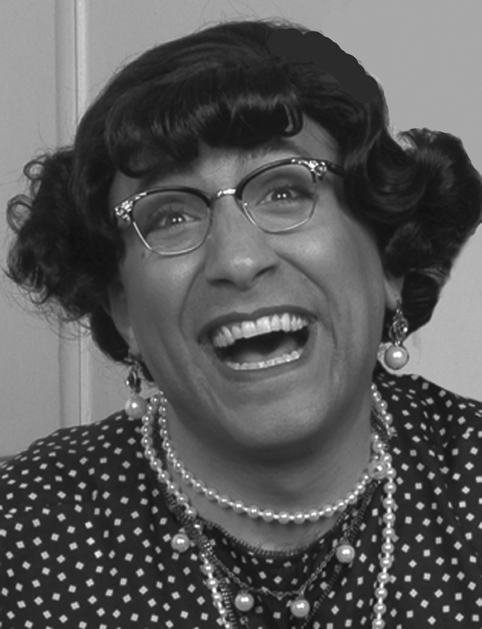
FRANCIS FORD COPPOLA (Director) is absolutely no relation to the famous Hollywood and multiple Oscar winning writer/director/producer. However, after graduating from Brooklyn School of Refrigerator Repair, job placement was a problem, and began accepting directing jobs based on his serendipidous name. Francis has directed everything from commercials to stage musicals to classic theatre to movies to television. A true jack-of-all-trades, Francis has been considered for three different Broadway revivals slotted to star Linda Blair. Upcoming, he is directing an independent feature starring Gwyneth Paltrow, who plays a blues singer with a kizzy eye getting out of drug rehab and making a come back. They're using a prosthetic eye and there's talk of an Oscar. It's called Eye On The Prize and should be in theatres next summer. For more information about the film, to view Francis' resume, or to contact him about a job offer, please visit his website at www.fixyourfridge.org.

BIFF “THE HAMMER” CALAMARI (Scenic Designer) was given his nickname when he was an infant, preferring a standard claw hammer to a baby rattle. Who knew that the same tool would become his interrogation instrument of choice in the family business? Biff is the proud owner of Calamari Construction and Concrete since 1990, and has the distinction of not having a single client that’s not a member of his extended family. He dedicates this episode to all of his children, wherever they are and whatever their names might be. Visit his website:
www.hammerpluskneesequalsanswers.com

MARCO DiCRISCENDO (Arrangements and Orchestrations) is one in a long line of accomplished musicians spawned by the DiCriscendo Family. As a boy, Marco would harmonize with his dog, Wolfgang's, howling. In high school, he and his five siblings started "The 5 Mandolins," a music group dedicated to covering all of Barry Manilow's songs on five mandolins. He attended the infamous VanGogh School of Music in Atrani, Italy. Upon returning to the States after graduation, Marco created and developed the influential composition style known as the "floating key." Based on the singing of Britney Spears, the "floating key" pieces, the idea of a set key limiting the composition is eliminated and the music is keyless. He is extremely grateful that Delphine and Carmela saw his one-man cabaret entitled, They Told Me to Shut Up But I Didn't Listen, and asked him to become Mangia Italiano’s musical supervisor. Marco wishes to thank Jesus and Madonna -- the singer, not the Mother of Christ. He likes her too, but she didn't get him through puberty.
BRANDON JAMES GWINN (Assistant to Mr. DiCrescendo) His music for Underwear A Space Musical premiered in the 2008 New York International Fringe Festival. The show recieved 4 stars in Time Out, and has been produced subsequently around the country and as part of the American College Theatre Festival. Brandon is also the composer for the musicals: Hatter, The Happy Prince, If These Stalls Could Talk and Matchmaker, Matchmaker: I'm Willing to Settle. He is also a contributing songwriter for Speargrove Presents. Brandon is a popular performer and accompanist for multiple acts in NYC such as Molly Pope, Cole Escola, Erin Markey, and Justin Sayre. He is a regular at Our Hit Parade at Joe's Pub, and can sometimes be found behind the piano sipping cocktails at the legendary piano bar Marie's Crisis. Brandon has a group of awesome private voice students and is available for classes and coachings for voice and piano. He is a graduate of Middle Tennessee State University Theatre and Dance, McLean School of Music, and has a Master's Degree from the Graduate Musical Theatre Writing Program at New York University. He is a proud member of both ASCAP and the Dramatist's Guild of America.

LUCY LICCAPUNANNI (Stage Manager) was the only girl, having four elder brothers and four younger brothers. Learning to wrestle, hunt, and make up offensive pick up lines right along side her siblings, she became known as the 9th Liccapunnani Brother. She attended All-Girls Dramatic Academy of Hoboken where she stage managed the all-female productions of Frankie and Johnnie at the Clair De Lune, A Chorus Line, and Cat On A Hot Tin Roof. She left college and started a small theatre company in the East Village of New York City called the Angry Woman's Brigade of Musical Comedy. The NY Times called her adaptation of West Side Story using only amputees, "The most confusing piece of theatre ever created." Lucy is proud to be stage managing this amazing television show, having a great deal of admiration for Carmela's large talents and is grateful
to be a part of any project Carmela would like Lucy to be a part of, professionally or personally.

ROBIN McBOBBIN (Costume Designer) is thrilled to be outfitting the biggest celebrities in public access cable cooking. The third daughter and one of nine children of Patrick and Peggy McBobbin of the Bay Ridge McBobbins, Robin married into the Calamari family when she got knocked up by Uncle Gino. She has been sewing since she was four and a half, and insists on doing all of her sewing by hand. As a consequence, Aunt Robin has been legally blind since 1995. When she’s not creating new and fabulous costumes for the Calamari Sisters, she’s a bus driver for the Bay Ridge public school system.

TONY “SPARKY” OSCURAMENTO (Lighting Designer) first fell in love with electrics at the age of 5 when he put a ViewMaster disc between a power plug and an outlet and was shot across his bedroom by 120 volts of electricity. That one event determined his career path and his hairstyle, and Tony is now the proud Master Electrician at WFAT. Also, a prolific inventor, Sparky is the genius behind the At Home Shock Therapy Kit, the Electric Loofah Sponge with DC adaptor, and the Interactive Fuse Box. In his spare time, he enjoys playing strip poker and asking the other players to taser him.


www.TheCalamariSisters.com/Merchandise

